L 7. Self-motivation: evidences, locus of Control Domains
Self-motivation is responsible for driving initiative, enthusiasm, energy, commitment, passion and persistence towards our goals. It is about wearing a positive attitude towards life, thereby impacting our leadership and influencing skills.
Motivation adds flavours of intensity, direction and perseverance in achieving our goals. Self-motivation works magically if our emotions are well directed towards goal achievement.
Emotions are strong drivers of self-motivation. Too much emotional arousal could be detrimental. In the complete absence of emotional arousal, motivation is unlikely to be kindled. It is necessary to find the right balance between emotional arousal and being devoid of emotions, as both extremes are unlikely to lead to effectiveness.
In the absence of self-awareness and self-regulation, it is rather challenging to move towards self-motivation. When we are unable to manage the external emotional stimuli and regulate emotions, we tend to drift away from our achievement orientation and drive.
Motivation is not confined to renowned athletes, who constantly push themselves to excel. It is equally applicable to humans in all walks of life. Self-motivated humans have a sense of purpose and propel themselves to greater heights, despite all odds. Self-motivation stems from a high internal locus of control, driven by the inner voice of meaning and purpose. Those with high motivation tend to have a lesser external locus of control. In other words, they need lesser external influence to drive them towards achievement.
Optimism too is an important trait of self-motivated people. It is about looking at the positive side of life incidences and pursuing goals despite hindrances. It is the ability to constantly self-recharge, with the desire to achieve and contribute.
Self-motivation is also about choices, for example, the choice to take ownership and move ahead to achieve things even beyond the call of duty. The indicator for lack of self-motivation is being confined to the call of duty and not even fulfilling them effectively. Some men and women are not confined by the boundaries of accountability and strive to achieve more. Self-motivation is prevalent in world-class athletes, as they demonstrate an intrinsic drive to push themselves towards higher goals. Deriving motivation, with the help of only financial goals, is not self-sustaining. For people with El, self-motivation is driven by passion and a sense of purpose, which is why it is long lasting.
We are motivated to do things that are comparatively easy. Our brain resists taking up challenges and venturing into unknown territory, as it is only concerned with survival. The instinct for survival prevents us from taking risks and trying out new things.
Self-motivation works against the gravity of inaction and overcomes resistance of humans in an effort to maintain the status quo. The brain assumes that we have survived with the current status, hence resisting any change.
The primitive man, living in caves, could survive without being attacked by wild animals. Their instinct was to continue living in the caves, as it was a time-tested and proven survival method. It took several millions of years for man to walk out of the caves and settle in the plains. It happened gradually with the advent of the agricultural era.

EVIDENCE OF SELF-MOTIVATION
There are several proofs of self-motivation. It manifests itself in the way we think and act. Each of these evidence needs a closer look, so that we can imbibe and acquire them.
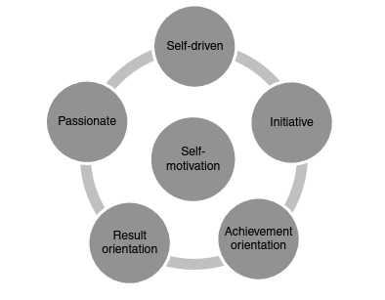
Driven towards goals and targets due to intrinsic drive, it also signifies the pursuance of goals, irrespective of external rewards and necognition. Self-driven people have an internal locus of control and seek pleasure in their accomplishments. External encouragement is not always consistent. Dependence on it may lead to disappointment.
Best of results are often achieved by people who are self-driven.
Initiative
It is the ability to seize opportunities on hand by choice. It is about taking charge of the situation to get things done rather than waiting for things to happen on their own or expecting someone else to act. It reflects personal willingness to get the job done. The contra indicator for initiative is lack of action. Initiative also involves the ability to take calculated risks and move ahead despite the possibility of failure.
Achievement Orientation
It is about the outlook towards the tasks on hand. It involves the flexibility to adapt to challenging situations with the necessary energy and mindset to overcome them. Keeping focus on the end result and continuously course correcting actions leads to achievement. It is ithe ability to learn from past experiences and constantly improving oneself.
Result Orientation
It is about recognizing the importance of achievement and the consequences of failure. The thought is needed to take the necessary steps to achieve the desired results on a regular basis. It involves being proactive and constantly reviewing and course-correcting when things are not going well. It is the focus needed on the outcome through consistent effort. It also involves identifying the best route to achieve the desired results.
Passion
When actions are clubbed with the emotion of love, it turns into passion. When passion drives our actions, financial goals and recognition become secondary. People with a passion for work go the extra mile to deliver the best possible results, not being satisfied with the ordinary. Passion fuels enthusiasm, which in turn generates the energy to drive towards results.
SELF-MOTIVATION AND EXECUTION
Self-motivation is needed for effective execution. Major gaps in execution are not due to a lack of good ideas or strategies. More often, the reason is the lack of execution skills. The ability to get things done is driven by self-motivation. According to Sumantra Ghoshal, execution needs energy on one side and 'focus' on the other. The absence of any one of the two leads to the derailment of the process.
Both focus and energy stem from self-motivation. Focus on the task on hand with no energy (mental and physical) would lead to failure in overcoming obstacles during execution. The contrary is also true.
Focus is developed with self-awareness and self-regulation.
Three Layers of Self-motivation
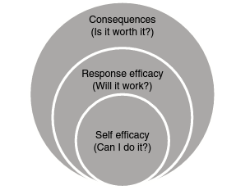
There are three layers of thought process leading to self-motivation.
Self-efficacy (Can I Do It?)
An affirmative answer to the question 'Can I do it?* will effectively initiate the self-motivation drive. Self-confidence in achieving the goal is the starting point. Failure to address this would make us a non-starter. Confidence in one's own ability comes from self-awareness. Hence, all the components of El are interconnected and lead to one another.
Response Efficacy (Will It Work?)
A strong self-belief that we can make it happen against all odds' is essential. It is the ability to visualize challenges and come up with plans to overcome them. If we are not able to think through them ivividly, we would most likely succumb to them.
Consequences (Is It Worth It?)
"Consequence, reward, benefit' factor ensures a strong drive for self-motivation. The human brain craves the experience of reward.
Given a choice, the brain wishes to maintain the status quo and save our energy for a crisis. It is constructed to resist change for reasons of survival. A strong negative or positive consequence will drive our minds to act. Hence, we need to reward the reptilian brain to overcome the resistance to change.
LOCUS OF CONTROL DOMAINS
Locus of control drives towards actions. According to E. Scott Geller, a behavioural psycholagist, there are three possible locus of control in humans.
‘I’ (Internal): 'My Results Are Controlled by Me'
When the locus of control is completely internal, the predominant thought is that "my actions and results are well within my control.* Such a thought arises from the perspective 'even if there are things out of my control, I shall work on them and correct them." Individuals with high self-regulation operate from the 'I' domain.
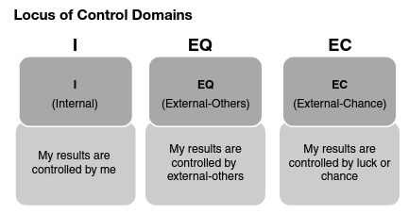
'EO' (External-Others): 'My Results Are
Controlled by External-Others'
Here, the domain is that My thoughts and actions are controlled by external factors and people around me. The belief is that others impact my ability to achieve the desired results as they are not in my control. The stimulus around the individual drives results. Individuals with lower self-regulation would operate from the 'EO' domain.
*EC' (External-Chance): My Results Are
Controlled by Luck or Chance'
Some operate from the domain of My results are determined by luck or chance and we have little or no role to play.' The results are not even dependant on self or the people around but rather left to the happenings of fate and luck. Individuals with very low self-regulation operate from the 'EC' domain.
SELF-MOTIVATION AND OWNERSHIP
Ownership stems from self-motivation. The word ownership' is derived from the word owner. The individual pursues the goal as he/she owns it. The sense of ownership is further fuelled by achievement orientation. Perseverance in pursuing goals, 'never-give-up' mindset, determination to overcome obstacles against all odds, all these attributes stem from self-motivation.
Accountability Statement
The most lucid manner by which we can understand and evaluate people on ownership is through the 'accountability statement. It is also an easy way to check our own ownership of the task at hand. This tool is an effective way to hold a mirror in front of us to understand the depth of our accountability.
In a bank statement, we have the credit, debit and balance columns to help us understand financial transactions. Similarly, the accountability statement has details of transactions such as what's going well', 'what's not going well' and the end result. It can be illustrated with the help of an accountability statement format.
Goal: Wish to Reduce My Weight by 10 Kg
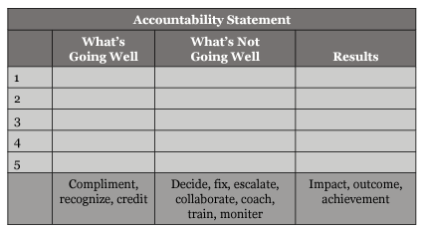
List all the tasks we need to undertake in order to achieve the goal in the statement. Against each of the tasks, list what's going well' and what's not going well. In the first column, we compliment, recognize and give credit to the deserving person and ourselves. In the next column, list the tasks that are not going well'. On the tasks identified, decide, fix the problem, escalate, train, coach, monitor and collaborate with others to get things done.
When we do the aforementioned exercise, results are bound to come by and we can claim ourselves to be 'accountable. The same principle is applicable to professional goals as well.
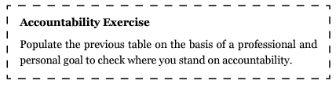
STEPS TOWARDS MOTIVATING SELF'
These steps are simple and would build the right motivation in us, helping us to develop achievement orientation.
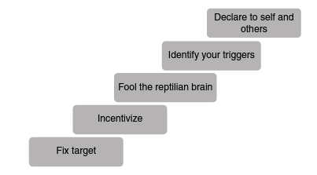
Fix Target
In order to move in the direction towards our goals, it is essential to fix targets and milestones. Or else this quote by Dr Steven Covey would be rather pertinent: 'If you don't know where you are going, any road will get you there.' If the target is written down, the goal is better etched in our minds.
It is the constant sight of the North Pole that helps us navigate through the high seas. Most often, wishful thinking occurs in our minds, with no concrete action to back them. If targets and goals are not written down and referred to often, they eventually face a natural death.
Incentivize
In order to achieve our milestones, it is important to incentivize.
Human behaviour is driven by pain or pleasure. It is always our endeavour to avoid pain and pursue pleasure. Incentives provide us with pleasure to look forward to, motivating us to strive hard to attain the goal at the earliest. Lack of incentive is one of the reasons why our drive towards achievement orientation diminishes over time. Not in all cases do threats work well enough to make changes in behaviour.
At times, it may be counterproductive. It could either lead to burying the head in the ground or get repulsive towards the desired change.
Hence, a positive stimulus is more effective. After initial rewards it might not be needed as our self-regulation takes over.
Fool the Reptilian Brain
All emotions are driven by the limbic system of the brain. We need to find a way to fool it by clubbing pleasure along with effort. There are creative ways to convert pain into pleasure. For example, waking up on a cold winter morning for a jog could be perceived as pain by the brain. In order to achieve the desired physical activity, the jog could be converted into playing a sport that we love with our friends. The objective of physical fitness and health is achieved and pain diminishes.
Identify Your Triggers
The trigger towards achievement orientation may differ for each person. It is important to understand the appropriate trigger that works for us individually. If it is blended with passion, it is likely to last longer.
The trigger for Viktor Frank, as narrated in his book Man's Search for Meaning, to survive the Nazi concentration camp under the most inhuman conditions, was the strong desire to not predecease his beloved wife. He imagined lecturing in his college post his release from the concentration camp. This was his trigger to survive, which gave him a strong sense of purpose. Once we identify our sense of purpose, the drive for achievement comes with comparative ease.
Declare to Self and Others
One of the initiatives that will help us to drive towards our goal is to declare our goal to others. This would further propel us towards achievement, as we would not wish to fail in the eyes of others. Our self-esteem is at stake and it appeals to our self-integrity and propels as further.

